Senior Minister Search
Candidate – Andrew Owens

Contents
Bio 1
McKnight Sermon: 1
Andrew Owens – Verbal/Email Feedback Summary 2
Andrew Owens – Google Forms Survey 5
Contact with Candidate: 5
Section 1: Sermon and Teaching – How engaging and relevant was the sermon? 5
Section 1: Sermon and Teaching - Was the message clear and biblically sound? 8
Section 2: Connection with the Congregation - How well did the candidate relate to different groups in our church? 9
Section 2: Connection with the Congregation - Was the candidate approachable and personable? 10
Section 3: Overall Impression - Do you feel the candidate would be a good fit for our church? 11
Additional Thoughts or Concerns 12
Excel Spreadsheet of Google Form Survey 13

Bio:
(per resume) I have been in Youth Ministry since 2011 at Vaughn Hill, and have been blessed to spend my entire ministry career there. My incredible wife Lydia and I have four children. Lyllian is 12, twins Ava & Zoey are 11, and Samuel is 8. My family is my greatest blessing from God and I learn from them daily. I love anything with a good story whether it is movies, audiobooks, comics, or video games, but ultimately, I love the incredible story we live in as a part of God’s redemption story centered around Jesus.

McKnight Sermon:
On June 8, 2025, Andrew Owens shared the story of his faith journey through plans he thought he would pursue and onto a path that God revealed to him along the way. Andrew asks us to consider where our faith in God might be, not just what faith we are comfortable with. We are challenged to examine our faith in the moments when faith is hard and to trust in God even then., and the video is available on YouTube here - https://www.youtube.com/watch?v=-eVXee7hfWI.
Andrew Owens – Verbal/Email Feedback Summary
June 8 weekend feedback

Below are comments received verbally or via email (not collected on survey form - https://tinyurl.com/yn7tvxsj.

Date | From | Comments
June 8, 2025 | Denise McCoy | “not impressed” – verbal feedback to Brad Stevens.
June 8, 2025 | Chris Fuller | We loved Andrew & his family! Highest endorsement from the Fullers!
June 8, 2025 | Nathan Strickland | Strong YES!
June 8, 2025 | Marion Earnhart | I only got to hear his sermon. I liked his perspective and authentic passion
June 8, 2025 | Colleen Murphy | I enjoyed Andrew’s service. He was personable and engaging. He presented the information in a way that was relatable to me. He felt like a good fit to me.
June 8, 2025 | Steve Jones | His message was ok. Spoke well. Not sure if he was given a topic or passage to work from and come up with the lesson plan or if he could use any sermon he already had in his files.  His family was dressed very appropriately but he went to a try out for a pulpit full time position looking like a slob.  That indicates to me he really doesn’t care if he gets the position so I would agree with him and he would be a no hire for me.  I appreciate your spirit and love for the church my brothers. I just tell it like I see it.
June 11, 2025 | Betsy Kelley | I only listened to the sermon.  Listened on you tube, so I was not present to see reactions in the congregation.  He is young.  His sermon caught me and kept my attention (a big thing for me).  His style of preaching is what I like about the Vail church’s preaching. Practical, grabbing and compared to real life.
June 11, 2025 | Betty Vaughn | I enjoyed meeting Andrew and Lydia and the children on Saturday evening and listening to Andrew’s message Sunday morning. He impressed me as one of the better candidates.  Andrew is personable and familiar with MX. He has worked with Nathan and Steve Awtrey which would facilitate his transition from youth minister to lead minister. A positive thing for me was his willingness to consult with Nathan and Steve before applying for the position.  Pros for hiring Nathan:  - He and Lydia both listen to the Holy Spirit and seek his guidance.  - He is sensitive to the needs of his kids.  - His experience as a youth minister is a plus for our emphasis on the NextGen ministry.  - Andrew is a ‘Collaborator.’  - His faith is important to him.  - He loves to learn.  - When presenting his lesson during class time, he was interactive.  - Andrew is approachable and willing to listen.  My only concern is the possible lack of experience in preparing a weekly sermon. I tried to find some of his sermons online but did was not able to find much. When he was in front of the church, he was confident and well-spoken and comfortable in the role.  From the interactions I had with Andrew and listening to him, I would be in favor of hiring him for the position of full-time lead minister. While this would be a different role for him, I will support and encourage him as he learns and grows if he is offered and accepts the position.
June 12, 2025 | Eric McPherson | Here are my thoughts on Andrew Owens and beyond:  I started as a NO on Andrew based on personal past experiences with him. There is not a concern about him morally or ethically, I just didn't think he was a good fit for McKnight based on what I knew. However, the Ministry Leaders interview changed me from a NO to a MAYBE. He has a good family and wife and gave some thoughtful and insightful answers. I am not sure about his leadership skills but am sure that he has a servant heart and is humble.  His sermon was pedestrian and fine. It sounded like a sermon to teens at a youth rally. It was not scripturally wrong in any way, but rather simple. However, I did strongly disagree with his story of getting a job because he went back and tithed missing contributions. That is not how God works. If he were our preacher, I would want to have a coffee with him to speak about this. "The rain falls on the just and the unjust".  I would be ok if we hired him although not excited. He certainly ranks higher in my mind that both of the Johns (Guenter and Blackmore) and would not be a bad choice. But is that what we are going for?  I am excited about the possibility of Devin Daniel trying out for the position. I personally have worked with him and Carly at Camp and know firsthand of his joy and passion for people and scripture. He is thoughtful and deep in his approach to the Word. He also would have some leadership skill concerns but certainly has all the personal qualities that I would want in a minister.  Here is my "Beyond " thoughts:  I would be ok if we hired Andrew and excited if we hired Devin, but I would be extremely excited and hopeful about our future at McKnight if we hired both.  Right now, we are paying 2 part-time employees in Jeff and Steve and looking for one full-time minister. What if we replace the 2 part-time positions with Devin and hire Andrew? The money would be close enough to make it happen ( I think). We certainly have enough work for the both of them. We could divide the responsibilities up between them and let them both rotate preaching so as not too overload or overwork them.  I think they both bring different approaches and skills that would complement each other.
June 12, 2025 | Kay Heintz | I was favorably impressed with his authenticity and apparent transparency. He appears to have an intimate relationship with the Holy Spirit, which in my view is an excellent base from which to grow into the role of lead minister.

Andrew Owens – Google Forms Survey
Below information summarized from the Google Forms Survey sent to McKnight congregation in various email and bulletin communications - https://tinyurl.com/yn7tvxsj.

Contact with Candidate:
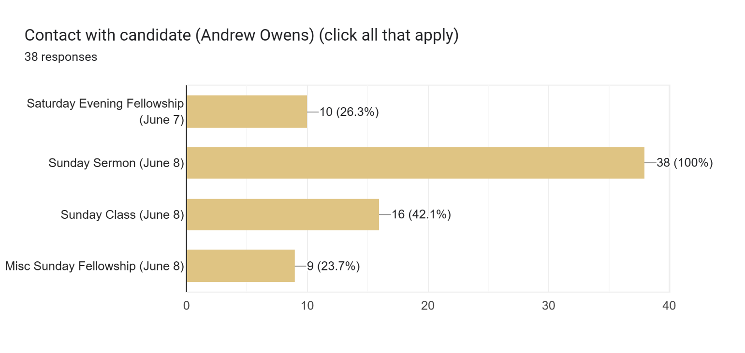

Section 1: Sermon and Teaching – How engaging and relevant was the sermon?

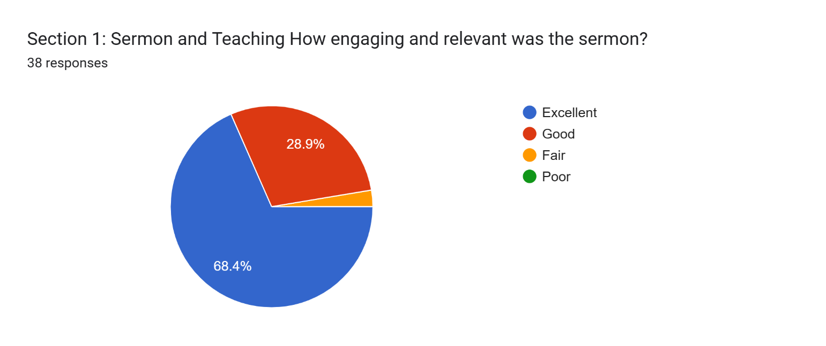

Section 1: Sermon and Teaching
How engaging and relevant was the sermon?
Add any comments here ...
35 responses

He did a good job of demonstrating how we have several layers of trust and how we can make it conditional.

I liked it

Extremely engaging. I understand it and felt like I could relate to some of the things he spoke about.

I believe he was very good with applying scripture to his sermon while making it very relatable. He kept me engaged with the way he applied different concepts and life examples to his message.

HIRE THE MAN

Often when I think about a sermon I consider if a friend at work or a neighbor would relate to it and find it refreshing or evoke curiosity. Andrew’s sermon did this, he was vulnerable, spoke clearly about faith in God.

I am a visual learner and was very engaged with Andrew's sermon. All of his visual's that he used were very relevant to "Leap of Faith." I was on the edge of my pew!

I really felt like he made his sermon relatable and able to understand.

Perfect mixture of lightness and seriousness. The trust drop was a good demo. Really got the point across.

He was animated in his movements and with his voice. Surprisingly good for someone who has not been a full time preacher.

He used real examples from his own life. That is important.

Enjoyed his energy, made us laugh, room to grow with preaching delivery. I like that young with potential for growth

I thought the sermon was good as he spoke on trusting God even in the hard times and in Bible class he brought up a very important subject on some churches being okay with pornography. I’m glad he was not afraid to talk about that.

It was very relevant and well-delivered. He kept our attention and I felt like I learned something very important from him.

I enjoyed the sermon and demonstration.

It was relevant and engaging, sometimes my mind wanders but he held my attention and I know I cry A LOT when I sing but the message brought me to tears.

Good visuals trust fall

super engaging and personable!

I think it had a particular all-ages appeal. Good balance of media, personal testimony, illustrations

The sermon was sound and Andrew's delivery was authentic and, at times, memorable. I know that Andrew has been a youth minister for 14 years, and I do think preaching every Sunday will present him with a challenge. I think he will have to figure out a method for study and preparation that goes beyond linking scriptures together around a theme. But I believe he is humble enough to learn with doing the job, and I think we should give him the opportunity to grow in this way while he is our senior pastor.

Andrew was very engaging and relevant. Held my attention from beginning to end.

He did a really nice job speaking in a manner that even our teens could follow the message. His role playing was a perfect analogy.

I thought he was engaging in relevant the entire time!

I like the examples and use of video during the sermon. I also liked the use of scripture and that the message was meat-and-potatoes (not overly heady or a discussion on esoteric theology)

You should hire him

He did great

Very engaging. Nice to hear his background and a good clear sermon on what faith is.
I understood it and found it relatable

Very good. He seems humble and is open about his failings

Very relevant

The sermon was engaging. I thought it was a bit like a youth ministry sermon and that he could have selected a topic that was a bit more in depth for adults.

HIRE HIM

Felt very surface level and basic. It did not hold my attention

Very good

Liked his message and presentation. I heard from a sister that the lesson resonated with her and was very helpful.

Section 1: Sermon and Teaching - Was the message clear and biblically sound?

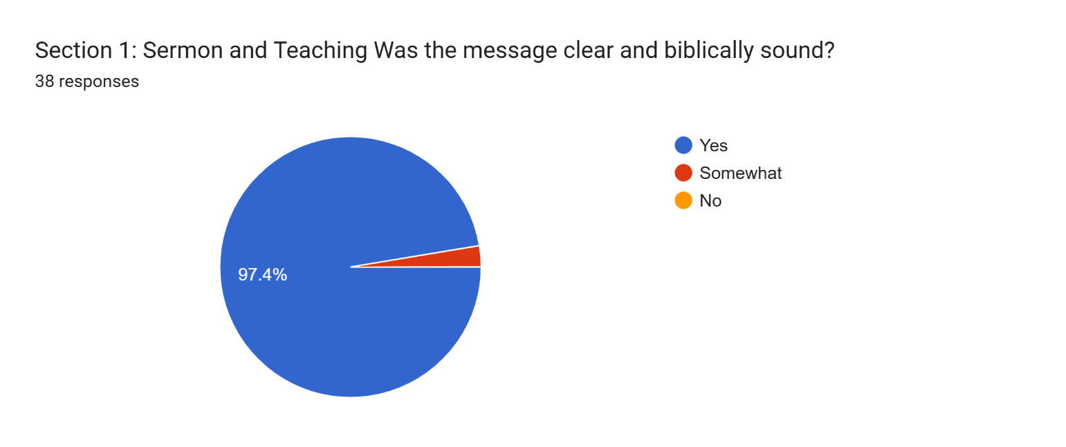

Section 1: Sermon and Teaching
Was the message clear and biblically sound?
Add any comments here ...
18 responses
Yes
Yes, very on point!
HIRE THE MAN
Very much so. We are taught to trust in God, and do what He wants us to do. Take that leap of faith!
Obvious knowledge of the scripture and ability to convey both context and meaning.
Plenty of applicable scripture references.
Yes - I think if he is willing to be a student of the word, he can continue to grow in his ability to teach and challenge and engage our church.
Trusting in God no matter what.
Good biblical basis. Lots of attention was paid to the text in the background study for the sermon, clearly informed the message
I could see that Andrew made a distinction between preaching and teaching, which was evident in the delivery. He is clearly used to teaching a younger audience, but I think he will learn to engage multi-generational attendees with time and experience.
Yes. I appreciated his clarity and transparency.
Scripture was well cited and sermon built around the scripture without stretching context or cherry picked to fit the goal of the sermon.
Yes, I understood it and it gotMe thinking
I was edgy about the interaction / participation but it turned out well.
HIRE HIM
Yes

Section 2: Connection with the Congregation - How well did the candidate relate to different groups in our church?

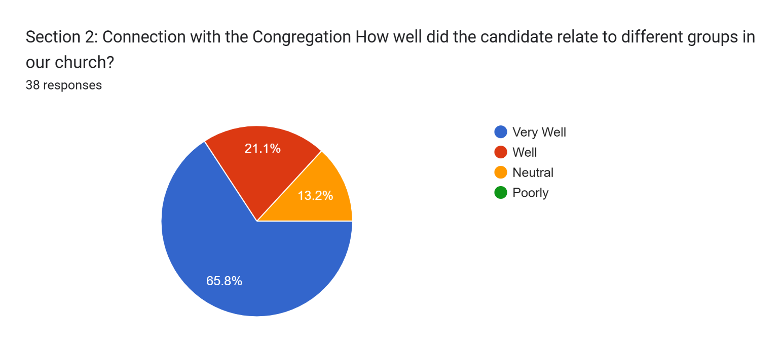

Section 2: Connection with the Congregation
How well did the candidate relate to different groups in our church?
Add any comments here ...
25 responses

During his sermon, he was transparent and showed some vulnerability
I felt the message was group neutral.
His eye contact and engagement was very much on point
Great! HIRE HIM
I don’t know . My hope obviously that he will connect with the oldies, young fathers, the lonely, retired couples , single moms, sick , you know what I mean . We could have amazing sermons every week but pastoring IMHO is more important. I met him and wife briefly. They both seemed perhaps a bit overwhelmed or tired. Most likely from the interview weekend. It must be a difficult process for a candidate and for the elders… thank you .
I felt like he drew in all ages with different scenarios and references.
Did a great job appealing to all demographics.
I did not really observe his interactions with others, this is a question people who went to the Saturday Night meeting will have to answer.
I didn't get a clear sense of his ministry/relational abilities. I would hope that his experience as youth minister has allowed him to learn how to connect with many people
I waited to introduce myself and saw how he took the time to speak with each of us. His wife was also nice.
I didn't meet him or his family so I have no opinion,
I watched from home so can’t really say how he connected there but I heard a lot of good feedback from friends who felt he was engaging
The audience was SUPER engaged so I would say very well. The youth group, parents, and older-folks were even responding to him and laughing when he made jokes and good remarks.
I thought he answered questions with sincerity and earnestness.
I am not sure how many groups he related to but they seemed to relate to many.
Andrew is very unassuming and easy to talk with. He seems genuine and relatable. His wife, Lydia, also seems very nice but is more reserved than Andrew (which is not a bad thing)
His kids would be a great addition, to youth group
He is awesome
I think his message should have related well. A sermon on faith should be received well by the church especially if it is engaging and illustrated well.
He would go and talk to everyone.
I think he is very relatable and relevant
HIRE HIM
I can't answer for others, but I thought he connected very well.
Very well
His message was not age based but truth, applicable for everyone.

Section 2: Connection with the Congregation - Was the candidate approachable and personable?

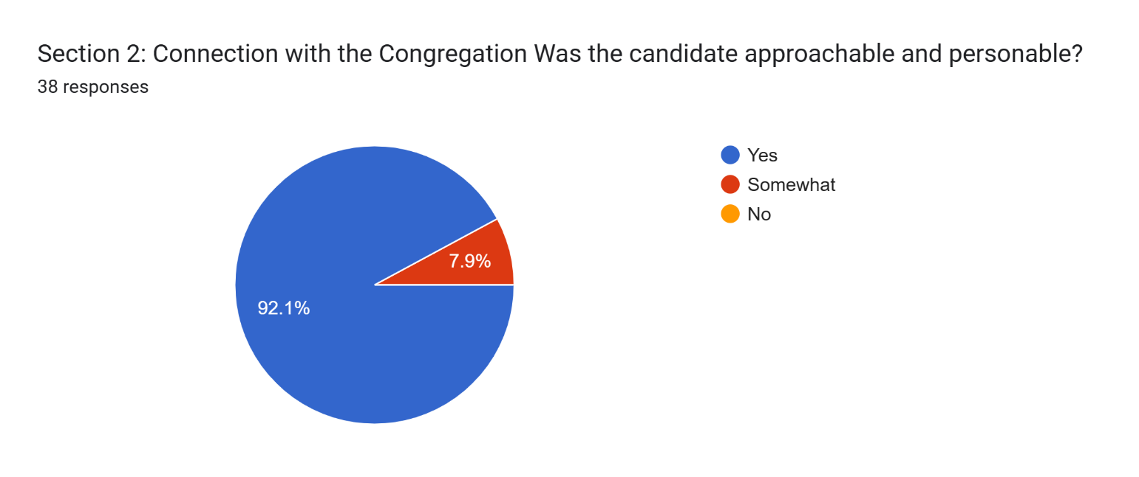

Section 2: Connection with the Congregation
Was the candidate approachable and personable?
Add any comments here ...

22 responses
Saw him engaging with a number of different people in the congregation.
I did not attempt to to engage..I had to leave quickly..:(
N/A
Of course! HIRE HIM
I don’t know Andrew so it’s hard to answer. He probably is. His children sure were ! Which reflects on the parents :)
Andrew was very approachable, and listened to what I had to say. Upon further speaking with him, I noticed how personable he was.
We just briefly met him personally, but had a good impression of both of them. Made me want to get to know them.
Casually conversational with me before church on Sunday. Felt like talking to someone I had known for a long time.
The teens seemed especially comfortable because they clustered around him at times.
Appreciated his authenticity and vulnerability. He seems humble too.
Talking any questions from us that we had.
I find Andrew to be approachable but have never had a deep conversation at lease we haven’t yet
Yes. I also believe Andrew's transparency helped create an approachable environment.
As noted earlier, I felt very comfortable talking with Andrew and as I watched the various interactions over the weekend it seemed that Andrew was able to engage well with many - both in a large group and individually.
He is nice, and seems nice
I spoke with him after church for a brief moment and he actually spoke to me first. Nice and easy going person.
He was very nice with starting conversations and just his whole family has and kinda always had even before he preached on Sunday.
Good
HIRE HIM
See my answer above.
Yes
He seemed very approachable.

Section 3: Overall Impression - Do you feel the candidate would be a good fit for our church?

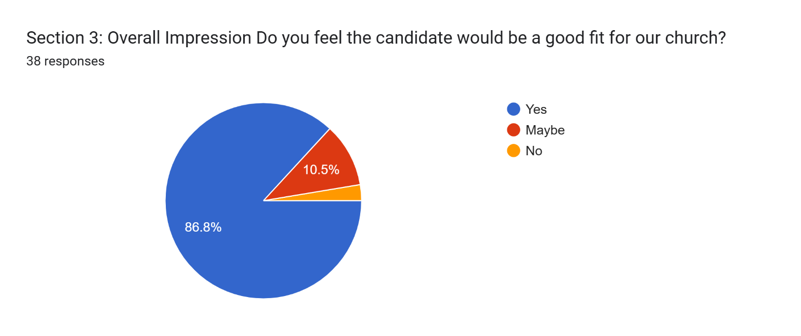

Section 3: Overall Impression
Do you feel the candidate would be a good fit for our church?
Add any comments here ...
26 responses
He seems to align with the culture and vision of MX.
I feel like I would like him…
Great Candidate!! I feel like he is the one for our church!
I would like to see he preach again if at possible but I did get a good feeling about his teaching method overall. His energy and story telling was great overall.
The entire yg loves him
Seems like it, I know I sound vague, sorry . I will support hiring Andrew .
When I met Andrew and Lydia Saturday night, I observed how comfortable he was being interviewed by us. THEN when I heard his sermon on Sunday, WOW, I was blown away with the ease of his words. He spoke like he had been our lead minister for years! I also attended his class, and truly had that "that's what that means" moment. He spoke from Daniel 1, on Daniel's faithfulness to God.
He is young and gifted and seems to me like a natural fit.
Very positive. He has a maturity of experience in life and ministry, yet also desires to grow further.
Yes - he seems a bit quirky but in a good approachable way. As a younger leader, I think he has lots of potential for growth
Another member and myself said we enjoyed the classes and thought he did really well.
I know Andrew but not well, he has always been friendly and kind. Even though Nathan and Andrew are friends, we decided we would go off of our own feelings and opinions. He is young, he brings four children but most importantly I can see he has a heart for God and His kingdom. Out of all the candidates we believe he is the best fit.
Yes, I think Andrew would fit very well with our congregation.
His age, his family his previous experience all make him a good fit.
I think he is open an honest, willing to speak out about the role of the Holy Spirit in his life, he seems willing to listen and seems approachable. I think he is exactly what we need.
Yes I think so!
Andrew may need time to develop his preaching but he seems to have a true heart for ministry, a genuine faith, and a pleasant and positive demeanor. He has worked with Nathan Strickland who has a very positive assessment of Andrew and his abilities.
Yesss
Yes, he fits well
Yes, and I appreciate his casual appearance. This is an approachable characteristic an a minister should be approachable and open.
Yes he would. He is young and smart and has stories to tell and lessons we can learn.
I think so. Please ask him if he sees the transition from being a youth minister and a pulpit minister .
He seemed comfortable visiting with everyone.
He would actually be an amazing fit
Yes
He already has what appears to be a good connection with Nathan and they would be working together.

Additional Thoughts or Concerns
Please write any other feedback here:

21 responses
He will need some coaching. We will need to be prepared to provide it for him.
We do need a younger outlook and this may help.
N/A
PLEASE HIRE HIM
Christianity is at an all time low in regards to respect, honor. integrity, and unity. My prayer is for us to live in such a way that makes the good news attractive, a pleasing aroma. Can Andrew guide us to flourish in our faith so people will want to know who the real Jesus is ?
Andrew's story of how he received the calling to be a minister, truly is Holy Spirit. Here is a man who has been a youth minister for 14 years, and God called him to apply for the lead minister position. He would be a breath of fresh air for our church!
The core strengths are there. Any weaknesses we note are not deal-breakers.
Just in the short time listening to him and meeting him, he seems to be a man that teaches the word of God and lives according to the way Jesus taught us to live.
At the risk of sounding petty, his clothes were sloppy and unprofessional. I can't imagine going to a job interview looking like he did.
We trust you, we trust God. You hired our son when the odds were against yourselves and Nathan.I don’t say that to lift my son up but to say, you trusted God and His will and I see the blessing of Him in our Youth Group. You have a hard job and we appreciate you all for the time you put in Shepherding.
His telling of feeling of previous calling to youth ministry and similar feel now is a good sign.
Hire the guy!!
I hope we offer Andrew the job. He showed poise, maturity, love, and wisdom in his time with us. I think he would fit not only the members of our congregation well but also our community.
I was impressed with how Andrew fielded questions during his Sunday class. He was able to think fast on his feet and provide good responses to some nonorthogonal questions. Andrew may need to grow in sermon prep and counseling. Overall I am impressed and can recommend Andrew without reservations.
Please hire him!
Nothing else to add
I really like their family and his lessons. He is a servant of the Lord. He works at camp teaching and directing and just in general a good guy.
I'd say give him a shot
I think he is a good candidate. Since he does not have experience as a lead minister, we might have to be a little patient as he develops his sermons and learns his role.
PLEASE FOR THE LOVE OF MY SOUL HIRE ANDREW OWENS
He stated that he is uncertain of his stance in regards to values I believe we need in a lead minister.

Excel Spreadsheet of Google Form Survey
Responses noted above are also available in an Excel spreadsheet here (with full details) - https://www.shepherd.mx.mxcoc.xyz/positions/docs-25/MX%20Minister%20Candidate%20-%20Andrew%20Owens%2006.14.2025.xlsx.

