Elders Meeting Agenda & Notes
Aug. 11, 2025
6pm – 8pm

Attendees: Steve Walker, Don Fitgerald, Brad Stevens, Bret Blackford, Dave Weiler, Steve Awtry (chair), Jeff McGlawn (visit)

Next meeting: August 18, 2025 – will discuss Messy Grace questions (see Attachment A below)

- Devotional
  - 6 Best Practices for Shepherding People in Congregations by Jim Martin
(see more at Misc. Documents #21 below)

- People

{{ various }}

- Onboarding Plan for Andrew
Steve Walker presented the following:
- Andrew Owens Onboarding Plan - .pdf or .docx
Reviewed and discussed in earlier meeting.

- List of Sick of Shut-in - .pdf or .docx
This is a list of individuals who are rarely at the church building. It was considered a good use of Andrew’s time to try and visit with most of these sometime over the next 12 months (preferably with another minister or elder).

- Small Group Ministry Reset
The health of our Small Groups was discussed and it was agreed they need more attention. We need someone to take the lead with our small groups and also feel that small group leader mentoring is important.

The Small Group Restart document reviewed is on-line here - .pdf or .docx.

Old list of groups here from Dale Simpson

Bret Blackford may have time to provide some leadership when retirement starts October 1, 2025.
- Bret would like to meet with small group leaders to pray, plan, discuss, cast vision, etc.
- Bret would like to start 1 or 2 men’s discipleship groups

- Eldership Plan
  - Possible future elders: Bardowell, McPherson, Eikle
  - Mentoring Plan - – Mentoring of potential elders is currently informal and may benefit from a more structured approach.
Steve Awtrey recommended going through the book They Smell Like Sheep: Spiritual Leadership for the 21st Century by Lynn Anderson. If we use this all elders need to commit to reading on schedule. We will use sections for our Elder meeting starting devotional.
  - Time Line:
    - Consider announcing Don Fitzgerald and Jeff McGlawn at 1st elder class (Nov. 9) or week before. List of classes recommended by the Christian Formation Team (CFT) here - .pdf or .docx. This list includes Elder’s Class in November as well as a Fall classes (including Steve Awtrey and Chris Fuller teaching from the book Unoffendable by Brant Hansen.
      - We give congregation two weeks to respond to Jeff McGlawn before he is “affirmed” as one of the Elders.
    - New potential elders (Matthew Bardowell and possibly Eric McPherson and Charles Eikle) would be discussed with the congregation after the November elder class.
  - Nathan’s Leadership Model – this has a new layer added between the Elders and the various ministries. This was presented for review before any further discussion or movement in this direction. Draft MX Leadership Development Model online here.

- Elder Meeting Chair Schedule 2025-26:

MONTH | ELDER
September / October | Brad Stevens
November / December | Bret Blackford
January / February | Steve Walker
March / April | Jeff McGlawn
May / June | Dave Weiler
July / August | Steve Awtrey

- Siebert Institute Analysis
Discuss at a future Elder meeting
Siebert Institute for Church Ministry – Church Health Assessment (CHA)

- Other:
- Steve Walker asked if we could announce that the Ferguson Heights CoC will have a 1st anniversary celebration August 31, 2025 (flyer here). Dave Weiler mentioned it would be appropriate to add that to our mid-week email.

- Steve Walker proposed the following Organization Chart (on line here)

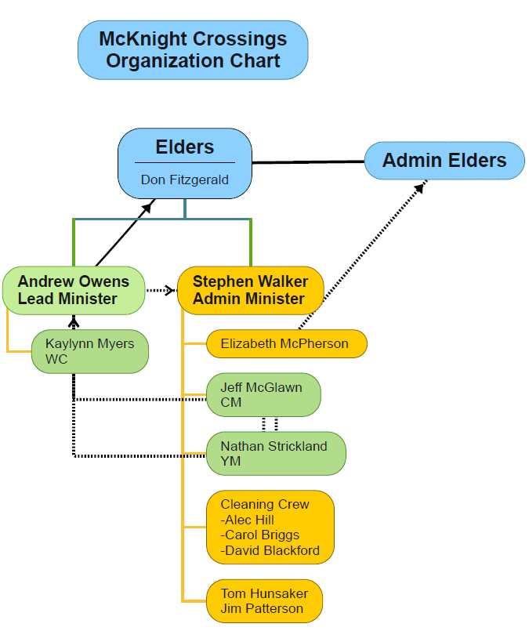

Attachment A
Messy Grace by Caleb Kaltenbach
LGBTQ+ Questions for Your Church to Consider

Would you allow a same-sex couple to attend your church?
What would the reaction be if two men were holding hands in the lobby of your building?
Could a lesbian couple who attend your church also attend a parenting class that you're putting on (because their child is in your children's ministry)?
Could an LGBT couple attend a community group or Bible study?
Could an LGBT couple serve anywhere in your church? If so, where? Why or why not?
Would an LGBT couple or person be allowed to go on a mission trip?
Would an openly gay man be allowed to attend a men's retreat if he wanted to?
What is the plan for the student ministry staff and volunteers when a teenager comes out or expresses same-sex attraction?
How do you love and support LGBT teenagers who are in your church?
Does your church have a plan to support parents whose kids have come out when the parents are unsure of how to respond?
What happens when someone involved in your church comes out and sees no contradiction between homosexuality and God's laws in Scripture?
Is your church a place where someone who has been in the LGBT community (but is currently not) can attend and be involved?
Would your church be open to having dialogue with people from the LGBT community who aren't in your church?
How does your pastor address LGBT issues in sermons?
What if a lesbian wanted to be baptized?
Could an openly gay man join your church as a member?
What would your staff do if an LGBT couple came to your church wanting to be married?
What would the reaction be if member had a sex change and still attended your church?

Misc. Documents:

- 2024 Member Info: Births, Baptisms, etc. – link
- Sr. Minister Search Summary document – here
- 2014 MX Gender Study: Women’s Role – here
- 2025 MX Gender Study: Women’s Role – here
- Communion Guidelines – here
- What Do We Believe? – here
- Betheline Outreach Center – link
- Qualification of an Elder: Study Documents – here
- What Are Elders supposed to Do? - link
- MX Shepherding Covenant – link
- MX Shepherding Model – link
- MX Core Beliefs – link
- MX Core Values – link
- Instrumental Music in Worship – link
- MX Welcome Packet (for new members) – link
- Elder Hospitality: draft document – link
- Mauritius – Canden Subarayadu March 2025 newsletter - link
- 2025 Church Calendar - link
- For The Bible Tells Me So, by Dr. Katie Hays – link
- MX Leadership Development Model (draft) - link

- Elder Growth and Training:
  - Often Overlooked Values of High-Functioning Elder Teams – link
  - Creating a Mentorship Program for Emerging Elders – link
  - 6 Best Practices for Shepherding People in the Congregation – link

“Chesterton's fence is the principle that reforms should not be made until the reasoning behind the existing state of affairs is understood. The quotation is from Chesterton’s 1929 book The Thing, in the chapter entitled "The Drift from Domesticity":

In the matter of reforming things, as distinct from deforming them, there is one plain and simple principle; a principle which will probably be called a paradox. There exists in such a case a certain institution or law; let us say, for the sake of simplicity, a fence or gate erected across a road. The more modern type of reformer goes gaily up to it and says, “I don’t see the use of this; let us clear it away.” To which the more intelligent type of reformer will do well to answer: “If you don’t see the use of it, I certainly won’t let you clear it away. Go away and think. Then, when you can come back and tell me that you do see the use of it, I may allow you to destroy it.”

― G. K. Chesterton

