Below are some notes regarding the 2026 budget draft that Dave Weiler and the Admin elders have prepared.

- The 2026 budget of $717,000 requires a 10% increase from 2025 projected contributions of $664,236 for break even
- For 2025, what is the Other Income amount of $16,952? Primarily interest (perhaps minimal rebates or refunds too)
- Note: we spend almost 3 days each week cleaning the building (21 hrs/wk) at a cost of $18,000/year
- Note: we spend almost 4 days maintaining the building (30 hrs/wk) at a cost of $39,200/year
- Per 3 & 4 we spend $57,200 on building cleaning and maintenance. Keep this in mind when we allow groups to use the building free of charge. Functions like pickleball, basketball, L’Arch, CFS, etc. do require extensive cost to McKnight and perhaps we should consider sharing these costs with the different groups (or charging break-even few for expenses). Free building usage is a ministry — but it is not “free” to the church.
  - Additionally, annual Facility expense (not rental house related) is $64,710/year, and much of this can be associated with mid-week building use.
- In 2025 we had a fund gain/surplus of $74,000. This is not due to extra contributions but a reduction in expenses, primarily payroll.
- Rental property added $18,000 to gain/surplus in 2025, budgeted to add $24,000 in 2026 (however, does not include any maintenance payroll of Tom Hunsaker and Jim Patterson).
- Missions is the second-largest expense category (roughly 15–18%).
• Missions remained steady or slightly increased from 2025 to 2026
This helps justify consistency in outward focus.
• Missions commitments are usually multi-year
This frames Missions as a stable and intentional part of McKnight’s identity.
• Does NOT reflect large $100,000 actually given to mission in Marseille France in 2025
- Health Insurance Considerations
- Health insurance continues to be a large and unpredictable expense for employees.
- There has been discussion about shifting from employer-provided insurance to employee-managed coverage through a stipend.
- This approach could stabilize budgeting and provide employees with greater flexibility.

Overall Story
The 2026 budget increases modestly in several areas (primarily Payroll), while holding steady in Missions and Facilities. The church is financially healthy heading into 2026, but the budget depends on a 10% increase in giving — a reasonable but significant lift. We must communicate clearly, transparently, and gratefully, highlighting the value of ministries supported by these funds.

Below is 2026 BUDGET

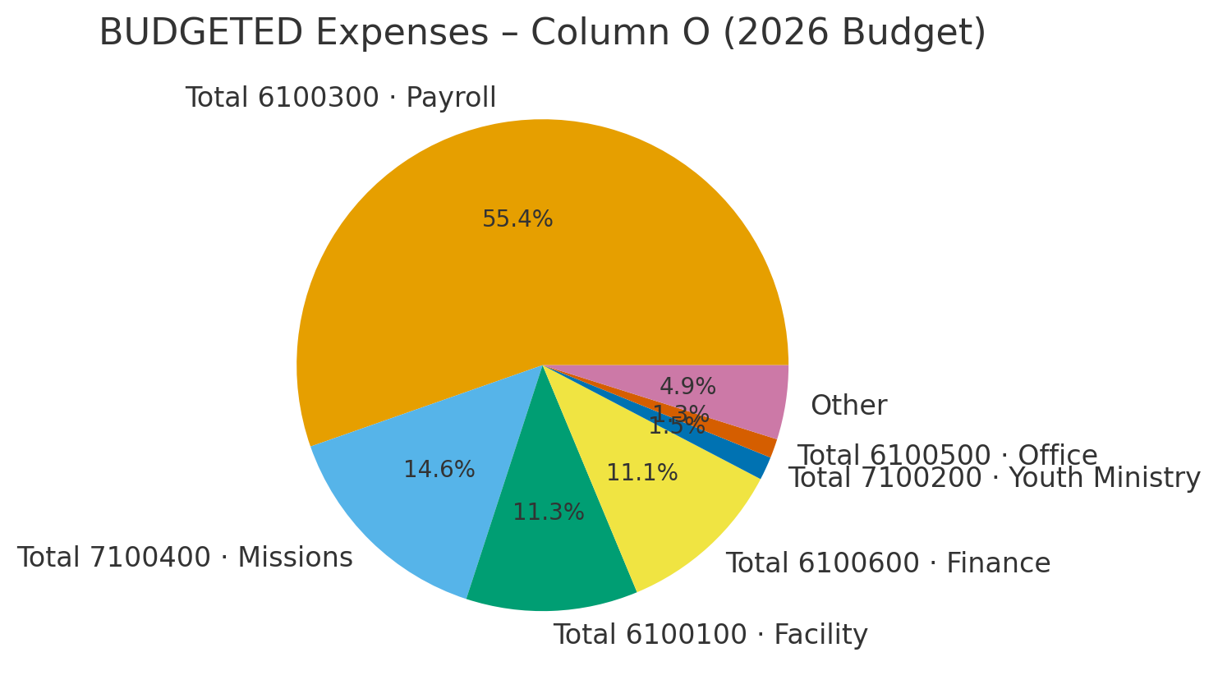

Below is 2025 Projected ACTUAL
