Elders Meeting
March 15, 2024
6pm – 8pm

Attendees: Steve Walker, Don Fitgerald (chair), Brad Stevens, Bret Blackford, Dave Weiler, Steve Awtry, Jeff Kryder, Jeff McGlawn (visit), Ross Brown (visit)

Next mtg.: April 1

- Devotional
Read Psalms 37 – “… rest in the Lord … do not fret …”

- People
{{ various }}

- Children’s Minister Update – Jeremiah H.
Easter Extravaganza with egg hunt
3-5th grade class has some behavioral issues

- Sr. Ministry Search Updates – Steve Awtrey

- Summary Document on-line here - https://tinyurl.com/yc8p8tyn.

Consider 1 Samuel 16 and Judges 7 during this process.

- The elders evaluated the four current candidates: Patrick Barber, Ethan Laster, Josh Nix, and Michael Santiago.
- The process for evaluation was as follows:
  - Elders rank candidates cold – without input from others
  - Discuss candidates
  - Elders rank candidates again
  - Summarize second rankings
  - Discuss next steps (based on rankings)

Results of rankings pre/post discussion noted at Attachment A.

- Patrick Barber was considered worth a second Zoom interview. The Vision Elders will work to schedule something with Patrick ASAP. Again, no need to schedule around elders’ availability and only need to worry about Vision Elders and Patrick’s timing/schedules. As with other interviews, the same questions will be used, and the Zoom recording will be made available to all.

- Recommendations – the Vision Elders have also been tasked with following up on recommendations for the top three candidates – Ethan Laster, Patrick Barber, and Michael Santiago.

- After reviewing Patrick Barber’s second interview the elders will decide which two candidates we would bring in to spend a weekend and preach. It is preferable if candidates can preach back-to-back on two contiguous Sundays. The intent is to give the congregation a look at the candidates and allow the elders to decide if one, both, or neither are worth bringing back for a second weekend which would involve more meetings along with the Sunday preaching.

Jeff Kryder is out April 14 so it would be a good Sunday for a guest speaker.

- The Elders will make the decision on the minister to replace Jeff Kryder. The elders should prepare to discuss the pros and cons of any candidates that have made it past the 2nd on-site visit. It is expected that there will be elders with differing opinions on candidates and we will need to come to a consensus. A unanimous decision is unlikely, but we need to come to a consensus and then be unified in supporting the decision and the recommendation to the congregation (see also #s 4 & 5 of the Sheperd’s Covenant here - https://tinyurl.com/arbttkcc).

- Summary of next steps:

  - Hold 2nd interview with Patrick Barber
  - Vision Elders review recommendations for Michael Santiago, Patrick Barber, Ethan Laster
  - Elders review Patrick Barber Zoom
    - Decide to bring in Patrick and/or Michael Santiago for on-site preaching.
  - Schedule on-site preaching weekend (hopefully contiguous) for top two candidates. Jeff Kryder out April 14 so a good day for a guest preacher.
    - Evaluate weekend with candidates.
    - Get input from congregation.
  - Schedule a second on-site peaching weekend with more structured time with elders and key members of congregation.

- Gap Analysis
After hiring of pulpit minister the elders need to understand if there are gaps between current abilities, what can be learned, and what is still needed. See Attachment C for the five attributes of a minister. Are we willing to hire to fill the gaps? How do we on-board and support the new minister?

- Faith in Action – April 21, 2024
Steve Awtrey will be on a beach somewhere so Don Fitzgerald and Bret Blackford will help get a list of projects and direct work crews. There will be a combination of projects around the building as well as a few at neighborhood homes.

The on-going list of building projects is available on-line here - https://tinyurl.com/2svvj695.

- France (Marseilles)
No money was sent to France. Will wait to determine if any individual contributions need to be returned soon to donors.
See additional detail in email at Attachment E.

- Children’s Ministry Search
An important question was raised –
Q: After having a full-time children’s minister on staff for a couple years do we see the expected value? Would it be a better use of resources to look for a part-time children’s minister and also look for an additional minister to fill-in some gaps – family ministry, worship, evangelism, etc.?

Interim: Jeff McGlawn will take the lead in the children’s ministry starting April and can continue in this role for several months. Expected to work 12-15 hours a week. Additionally, Izzy Henegean will be an intern in this area for the summer, working around 30 hours a week @ $14.50/hr.

Interim Children’s Minister Coordinator job description – see Attachment D.1
Interim Children’s Minister Intern job description – see Attachment D.2

Josh Brown and Jason Vincent are heading up the search team looking for the next Children’s Minister (full or part-time). Children’s Minister Job description on-line here - https://tinyurl.com/3bjkyv75.

- Misc.
- Directory: on-hold for review and discussion at future meetings.

MX Youth Group Newsletter (March 11, 2024) – here - https://tinyurl.com/munccy5n.

Weekly Bulletin (March 20, 2024) – here - https://tinyurl.com/mpaarsx3.

Attachment A

Ranking sheet also on-line here - https://tinyurl.com/ys3vbkzk

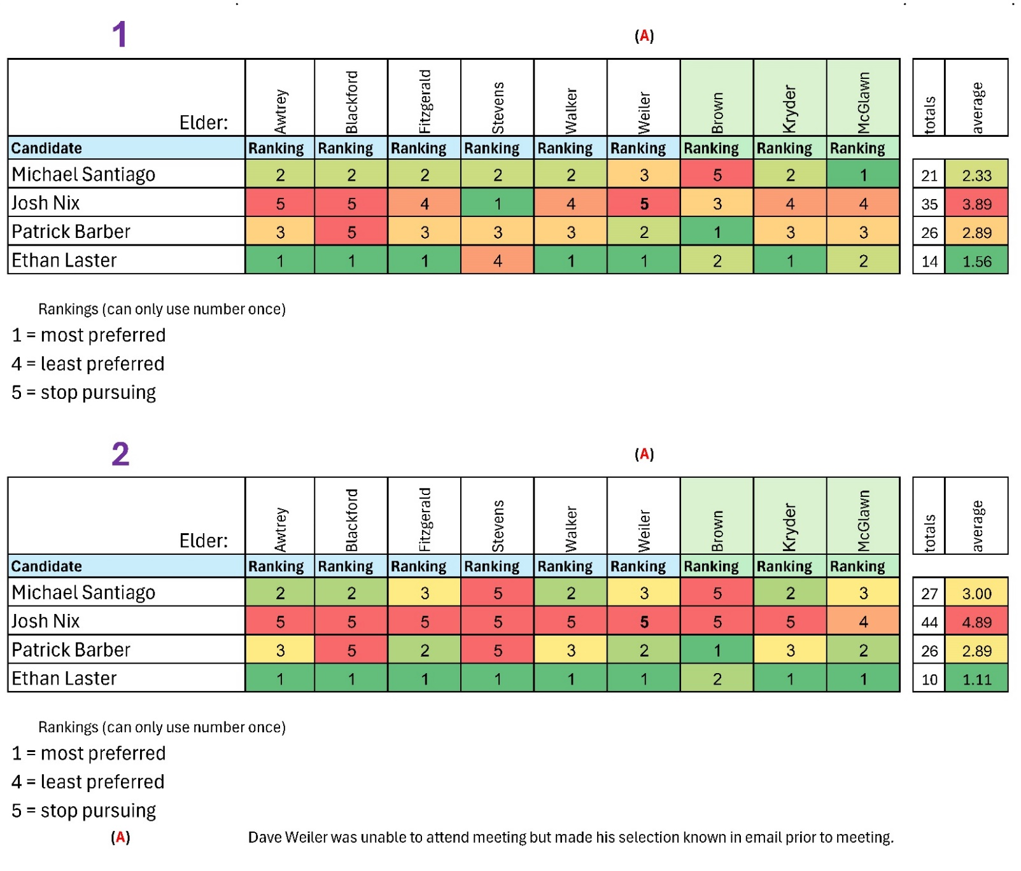

Per the above ranking Ethan Laster is clearly the strong favorite and Josh Nix would not be a good candidate.

All candidates had their strengths and seemed to have a genuine call and desire to serve in ministry and should be encouraged to do so, but Ethan is currently checking off more of the boxes we are looking for here at McKnight.

Attachment B

Minister Search Timeline
 |  | McKnight Crossings Church of Christ
 |  | New Minister Search Timeline
. | . | 2023 |  |  | 2024 |  |  |  |  |  |  |  |  |  |  |  | . | .
 |  | Oct | Nov | Dec | Jan | Feb | Mar | Apr | May | June | July | Aug | Sept | Oct | Nov | Dec
 | Soft Search |  |  |  |  |  |  | Hard Search (starts April 1, 2024)
 |  | (A) | (B) |  |  |  |  |  |  |  |  |  | (C) |  |  | (D)
 |  | (A) | Congregation notified in October 2023
 |  | (B) | Jeff turns 64 November 23, 2023
 |  | (C) | September 1, 2024 Jeff Kryder stops preaching
 |  | (D) | December 1, 2024 Jeff Kryder off payroll
 |  | Note 1: | Elders decided new minister can be brought on whenever suitable replacement found, even while Jeff Kryder still preaching.
 |  | Note 2: | Outside resources, such as Siburt Institute, will be utilized to help find candidates.

Attachment C

Presented at the March 25, 2024 McKnight Elder meeting

5-Fold Leadership Model + Executive

The 5-Fold model is based upon Ephesians 4:11-13: ¹¹ So Christ himself gave the apostles, the prophets, the evangelists, the pastors and teachers, ¹² to equip his people for works of service, so that the body of Christ may be built up ¹³ until we all reach unity in the faith and in the knowledge of the Son of God and become mature, attaining to the whole measure of the fullness of Christ.

- Apostles – extend the gospel. As the “sent ones,” they ensure that the faith is transmitted from one context to another and from one generation to the next. They are always about the future, bridging barriers, establishing the church in new contexts, developing leaders, networking trans-locally.

- Prophets – know God’s will. They are particularly attuned to God and his truth for today. They bring correction and challenge the dominant assumptions we inherit from the culture. They insist the community obey what God has commanded.

- Evangelists – recruit. These infectious communicators of the gospel message recruit others to the cause. They call for a personal response to God’s redemption in Christ, also draw believers to engage the wider mission, growing the church.

- Shepherds - nurture and protect. Caregivers of the community, they focus on the protection and spiritual maturity of God’s flock, cultivating a loving and spiritually mature network of relationships, making and developing disciples.

- Teachers - understand and explain. Communicators of God’s truth and wisdom. They help others remain Biblically grounded to better discern God’s will, guiding others toward wisdom, helping the community remain faithful to Christ’s word.

Added:

- Executive – Administrate operational aspects. They play a key role in strategic planning, human resources, finance, recruitment, and all functional activities to ensure alignment with and accomplishment of the church's mission and vision.

Attachment D.1

Presented at the March 25, 2024 McKnight Elder meeting

Responsibilities for Interim Children’s Minister Coordinator (12-15 hours per week)
- Plan and serve in curriculum & events for ministry to Children ranging in life stage from newborn to 5th grade.
  - Children’s Worship
  - Bible Classes
  - Nursery
  - Milestones in Worship
  - Big Events (VBS, Back to School, Trunk or Treat, Father Daughter Date Night) - limited
  - Other Events in partnership with Youth Minister
- Available to families, Discipleship Leaders, and Volunteers on Sunday mornings.
- Communicate content summaries (weekly newsletter) & upcoming events with families and congregation through various print and social media venues.
- Recruit, train, & coach Discipleship Leaders and volunteers to serve various roles in the ministry.
- Participate in meetings with staff and elders (2x per month)
- Build relationships with families of Children and with our church family.
- Facilitate monthly Children’s Ministry Council meeting & leverage input.

Attachment D.2
Presented at the March 25, 2024 McKnight Elder meeting

Responsibilities for the Intern to the Children’s Minister Coordinator (CMC). The intern will work approximately 30 hours per week. (Three 8 hours on weekdays and 6 hours on Sundays)

Provide assistance to the Interim Children’s Minister Coordinator. Helping him with implementing curriculum & events for ministry to Children ranging in life stage from newborn to 5th grade. These include:
○ Children’s Worship
○ Bible Classes
○ Nursery
○ Milestones in Worship
○ Big Events (VBS, Back to School, Trunk or Treat, Father Daughter Date Night) -

- Under the guidance of the CMC the intern will provide assistance to fulfill the duties required to staff and prepare the nursery for Sunday mornings.
- Under the guidance of the CMC the intern will provide assistances to fulfill the duties required to prepare the Children’s bible study classrooms for Sunday mornings. Including making sure classroom materials are in rooms, volunteers have teaching materials and confirm adequate staffing as prescribed by CMC and preparing bulletin boards.
- Helping with NextGen milestones and big events.
- Attend NextGen meeting on Tuesday mornings and weekly staff meetings.
- Other duties as assigned by CMC and Senior Minister.

Attachment E

From:deb.debbi@gmail.com
To:Jim & Frederique Griffith
Cc:Steve & Ann Haupt,Weiler, David and Amy,Steve Walker,Keaton Jones,Steve Awtreyand 9 more...
Sat, Mar 23 at 11:46 PM

Dear McKnight Missions Committee and Elders (sorry I do not have all the email addresses),

It is hard for me to put this in writing. After all the prayers, uncounted hours of preparation and expressions of generosity, the seller has put on hold the sale of the monastery. It has made for a very difficult past six weeks. While we have had our ups and downs over the last 34 years, this news is hard to swallow. Still, as Paul writes in 2 Cor 4.8, ‘We are hard pressed on every side, but not crushed; perplexed, but not in despair.’

You have been so good to us. Before the details, we want to thank you so much for your partnership and generosity in helping to even make this project possible on our end. We pray that we will still see it come to fruition one day.

We had everything set and agreed on. But on the day we were supposed to sign, the seller modified a clause (potentially modifying the price). Unfortunately, of course, we do not control the integrity of those on the other side of the table in these transactions. Our notary public and lawyer stated that such a change was not acceptable and asked the seller to reword the clause. We expected the process to take a week and then we’d sign and be on our way.

That is why our communication with you has been on hold. We thought it would just be a matter of days. After two weeks we asked what was happening, and when we finally got an answer, the seller said they were waiting for a meeting with a lawyer on their side that will take place in another couple of weeks. After six weeks we have now finally received word that for the time being, while they figure things out, they have put the sale on hold. We continue to pray that things will work out, but clearly, it may take a long time.

So we have no choice but to put everything on hold on our end and ask you to please not send contributions for the monastery until we have a clear path forward. What is not on hold, of course, is continued prayer that despite the setbacks, God would open a way forward.

We thank you so much once again for your love, partnership and generosity, and especially your prayers at this time.

Together in the mission,
Craig and Katie

