**MX Shepherds Meeting**

February 21, 2022

Attendees: Brad Stevens (chair), Wole Okunade, Jon Earnhart, Bret Blackford (notes), Keaton Jones, Don Fitzgerald, Steve Awtrey, ~~Steve Haupt (chair),~~ Steve Walker, Lane Hamm, Louis & Joyce West,Dave Weiler

Jeff Kryder

**Joyce & Louis West:**

A new way to get to our destination. Discussed a **logic model**, to document plan for change.

Inputs: out 7 values.Outputs: who are we going to reach & what are we going to do to reach our outcomes.

Get a diverse group of people together and create a Theory of Change Logic Model. Joyce is willing to get these people together. A good primer on *Theory of Change and Logic Models* noted in this article – [***here***](https://pcar.org/sites/default/files/resource-pdfs/tab_2018_logic_models_508.pdf).

Steve Walker: How do we breathe life into the 7-values? This tool may help us. Steve also wants the goals dynamic and allow the congregation a way to fit in.

1. Any updates or progress on several items from last meeting

* **Youth Group**

Lane Hamm – committee had 1st meeting. Already have a couple resumes but still plan to advertise (but need to find out how/where). Can/should we post on [***Indeed***](https://www.indeed.com/)?

Need to update website with 7-values and Youth Group info.

Jeremy Picker expressed interest in YG ministry. Dave Weiler asking about approach. Per Lane, Jeremy will need to apply like any other applicant.

Search Membership:

Jon Earnhart , Eric McPherson, Rachel Bardowell, Sara Matheny, Jeff McGlawn, Beata McGlawn, Steve Beauchamp, Coen Reigers, Sydney Bax, Grady Goff, Ansley Picker, Kennedy Picker

* **Safety Team**

Bret Blackford and Jon Earnhart working with Safety Team and developing new procedures requiring fewer volunteers. See **Attachment A**.

* **Live Streaming**

Jeannie Britzmann and Bret Blackford are currently reviewing bid/proposal from [Elite](https://elite1988.com/). Two parts to bid:

* update house lighting controls ~ $10,500.00
* add stage lighting ~ $20,000.00
* **Dale Robinson consulting on staff issues**

Steve Awtrey provides scope handout from Dale Robinson. (see **Attachment B**)

* + This work will have an impact on the two open positions we are trying to fill – the Youth Minister and the Children’s Minister.
  + Lane Hamm: What are our priorities?
* **MX Workdays**
  + Google doc signup [***here***](https://docs.google.com/document/d/1WmxPNFua3N93nkJkfSm2a2RcyI-1_02maNsmnrxml4Q/edit)

<https://docs.google.com/document/d/1WmxPNFua3N93nkJkfSm2a2RcyI-1_02maNsmnrxml4Q/edit?usp=sharing>

* + Keaton discussed the various projects and what we might be able to do, Most of these are older widows who need help. Probably will not cost much for the church outside of labor.
  + Bret Blackford to work with Brad Stevens on legal documents (indemnification of MX). Develop procedure for how to sign and informed consent.
  + Don’t get over your skis – keep in manageable. Start small and keep expectations reasonable.
  + All agree **this is a great ministry opportunity !**

1. Member news / issues / etc. (e.g. Lucrecia’s letter)

* Value key important members (prevent Hannell issue). We rightly spend time on those with needs, but do we invest/recognize those key members?
  + “Jars of Clay” recognition
  + Periodic (semi-monthly?) video highlighting a ministry or member. Jeff Kryder to work with Brian Hill and Jeremy Picker on this.
* Lucrecia was here this past Sunday and several talked with her.
* Brian & NeNe: Dave Weiler working with them on their car and financial counseling.
* Tim & MaryAnn Nicholson: in Dave Weiler (and Lane Hamm) small group.
* Steve Jones with detached retina.
* Keaton’s brother-in-law came home tonight from hospital.

1. Discussion on elders continuing to attend staff meetings

* Google doc [***here***](https://docs.google.com/spreadsheets/d/1GbanwBsEyVhAvG6CSIFeTGQtE6kJsac2xR4erx7SL54/edit#gid=0)
* Not required but a good idea. No big agenda needed just be present.

1. Feedback on speakers during sabbatical

* Jeff Kryder handled praise of guest preachers well in his sermon last Sunday
* Bret liked rotation 1x month someone besides Kryder preach.

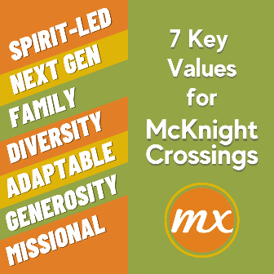

1.    **Spirit-Led**: [J. Picker] Prayerfully following the direction of God

2.    **Next-Gen**: [J. Picker] Investing in the next generation

3.    **Family**: [J. Vincent] Having a common Father to deeply love one another

4.    **Diversity**: [J. Picker] Sharing in our oneness; appreciating our differences

5.    **Adaptable**: [L. Hamm] Changing to better honor God

6.    **Generosity:** [D. Fitzgerald] Eagerly giving time, talent, and treasure

7.    **Missional**: [J. Fogarty] Purposefully sharing the good news as we go

1. Children’s minister update

Committee formed:

Jim & Dana Patterson, Leon Sewkarran, Jeff & Beata McGlawn, Jayson & Wilka Vincent, Laura Picker, Gwen Walker, Nana Taylor, Philip Matheny, Hanna Grimshaw, Jake & Jessie Munoz, Kate Schneider, Ross & Alicia Brown, Hanna Grimshaw, Heather Goff, Matthew Bardowell, Adam Shelly

* Committee to work thru job description that will be brought to Elders for review.

1. Jeff Kryder sabbatical comments / questions

* Jeff Kryder to prepare 3-year plan
* Elders to determine job description for new minister
* Jeff Kryder found the sabbatical very helpful. Lots of reflection time in a cabin alone, as well as visiting family. Visited a therapist (which is helpful!) and learned a lot about himself (like slowing down his mind). Quote from a book: “What the congregation needs is transformed leaders” (leaders that seek God’s transformation in their lives as an example to others).
* Dave Weiler: It was also good for the Elders to take leadership while Jeff Kryder out. Warns that we do *NOT* want Jeff Kryder to revert back to the mean (back to the problems that burdened him before sabbatical).

1. Church governance thoughts / ideas / next steps

* Wait on info from Dale Robinson (see Attachment B)

1. Date for Glen Davania recognition and John Earnhardt announcement as intern

(Glen & Janice Davania were at church on the 13th for the first time in a long while)

* Steve Walker to contact the Devanias to find a good time to recognize them
* Jon Earnhart notice – provides an openness and transparency with the congregation.
* Steve Awtrey: reminder of elder sabbatical.

1. Date for AJ & Susan Bennett sendoff (announcement only or reception)

* Bret Blackford to help schedule something with ACTS group and McKnight Church

1. Ideas for connecting with absent members (as pandemic numbers are dropping)

* Have some events? Picnics, pot-lucks, etc.

1. Other items (if time permits)

* Ne-O-Tez Family Day: Encourage members to get together there at Ne-O-Tez. We need to spend time together!!
* This is Heather Goeff’s last week. We should do something to recognize Heather being gone.
  + Don Fitzgerald to get Flowers & card to present on Sunday
* Dave Weiler chair March mtgs.
* Elder Mtgs: How to get staff involvement? How do we hear from other ministries?

**Attachment A**

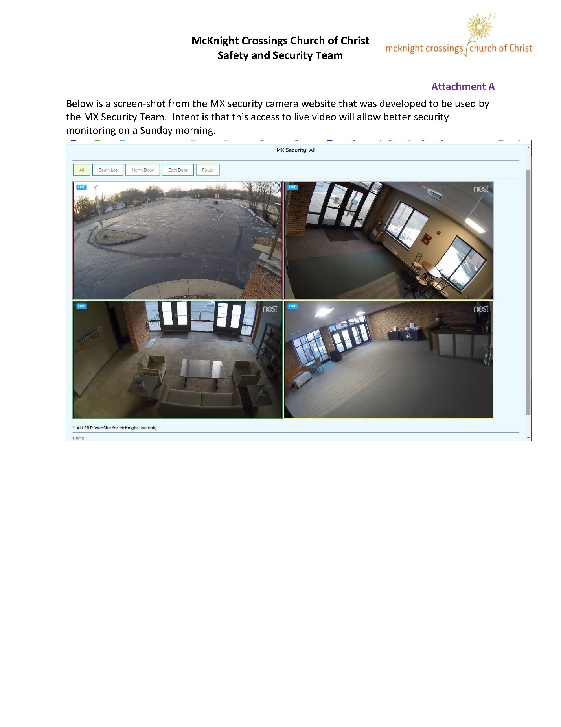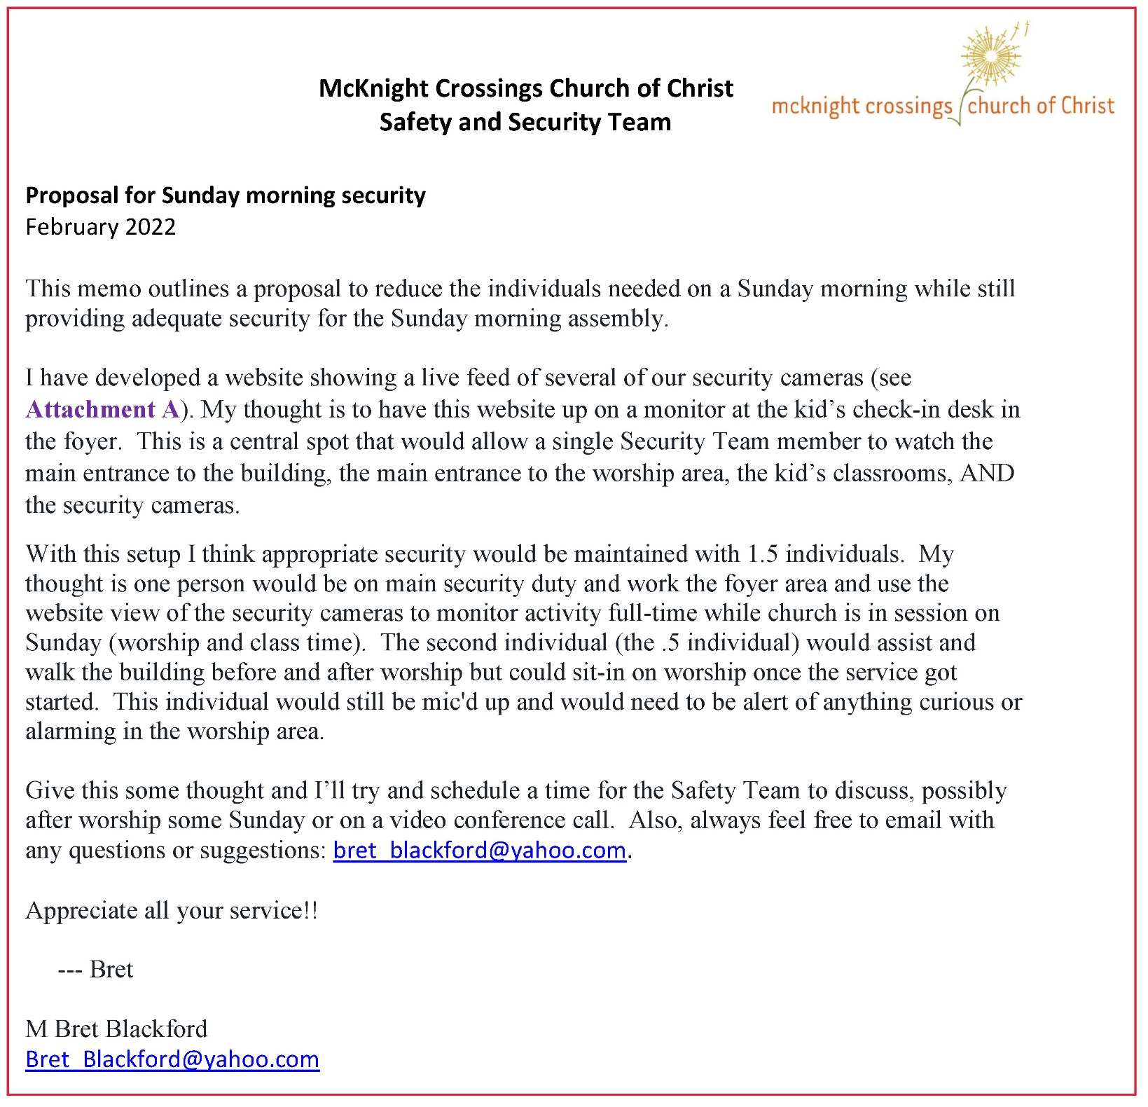

**Attachment B**

**McKnight Crossings Church of Christ**

**St. Louis, MO**

**Consultancy Proposal**

**February 2022**

Prepared by: Dale Robinson

Proposal and scope of work initially consists of assessing present church staff strengths and challenges, along with a review of organizational processes and technology needs. As envisioned, the work falls into three stages as noted below.

1. Listening and Data Gathering.
   1. Interviews with Elders—in groups of twos or threes.
   2. Interviews with Ministry and Support Staff—individually.
   3. Review of all policy documents, elder covenants, job descriptions.
2. Reflection and Discerning
   1. Summary report on interviews and document review to elders and staff (separately or together).
   2. Facilitation of action plan that emerges out of this season of reflection.
   3. Revision of job description(s) and development of staff minister(s) search process to fill anticipated vacancies and/or identified needs strategically.
3. Implementation of Action Plan
   1. Assist implementation of any changes with appropriate groups: elders, staff, congregational teams, etc.
   2. Assist implementation of search process plan.

I would propose that we begin this consultative relationship beginning February 17, 2022 and anticipate the initial assessment to be completed by March 21, 2022. McKnight Crossings will cover expenses and a rate of $50/billable hour. The relationship can be renewed or altered by either McKnight elders or by Dale Robinson.